**Cost optimization project**

In order to optimize cost, we need to ensure that the resources are available only when needed. And when the resource utilization is complete, the resources are stopped automatically. This can be approached in a number of ways as detailed below:

1. Develop a pipeline which pauses your DWH and loops until the pause is complete as shown below:

Set the following parameters upon execution of the pipeline:

* **SubscriptionID** - The GUID identifier for the subscription the Azure SQL DWH is running from. To get this ID, go to the Subscriptions tab of the Azure Portal.
* **ResourceGroup** - The name of the resource group where the Azure SQL DWH lives.
* **Server** - The name of your Azure SQL DWH server. This is not the full yourdwserver.database.windows.net server name. This is just the initial your DWH server section.
* **DWH** - The name of the DWH database

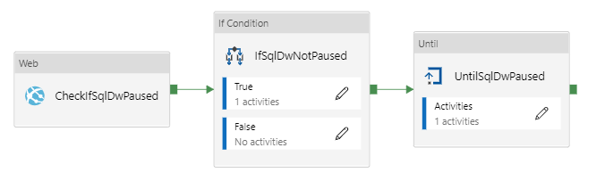

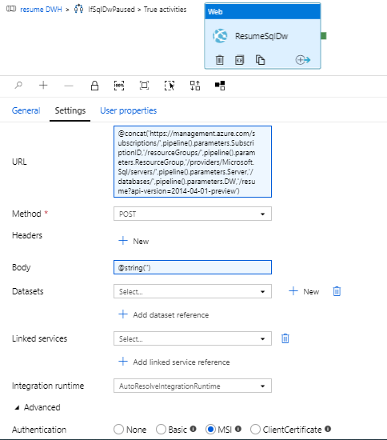

This pipeline executes the command under your ADF Managed Service Identity (MSI). Thus that MSI must be granted proper permissions.

Similarly a Resume-DWH pipeline will be developed and will be called in the required pipelines as below:

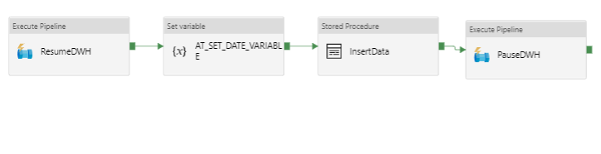

1. Develop a PowerShell runbook in Azure automation account and use a webhook within a PowerShell script then call it in the our ADF using webhook activity.

The below commands could be used in the Powershell runbook:

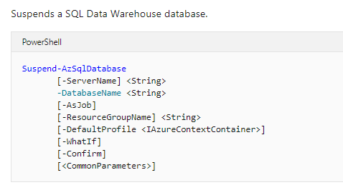

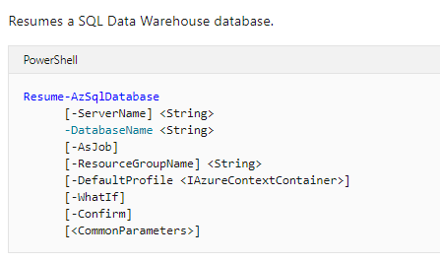

**-AsJob :** Runs cmdlet in the background

**-Confirm :** Prompts you for confirmation before running the cmdlet.

**-DefaultProfile :** The credentials, account, tenant, and subscription used for communication with azure

**-WhatIf :** Shows what would happen if the cmdlet runs. The cmdlet is not run

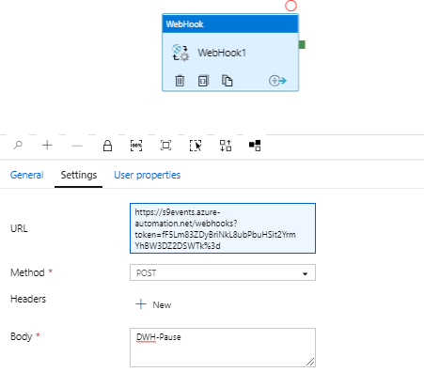

1. Create a .NET containerized application and to access the resource and change its state and then call the application’s executable file into a custom activity in ADF as shown below:

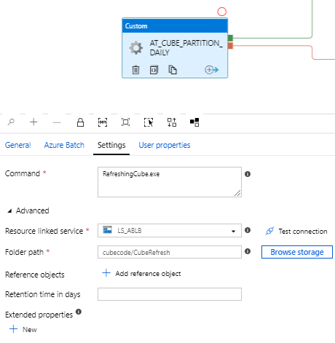

Folder path will be the path to the container folder path of .NET application